Requirement Analysis

* Server environment
* **Machine:** A physical machine (MacBook Pro)
* **Operating System:** Mac OS
* **Web application infrastructure:** Apache + PHP + MySQL by XAMPP
* **Websocket:** Rachet websocket server on port 8080
* **Deliver Media Stream Server:** RTMP server on 1935
* **Domain Name:** [bubblebeetv.sytes.net](http://bubblebeetv.sytes.net) ( 30 days confirmation from no.ip.com )
* **SSL ( HTTPS ) Setup:**

1. Register a FQDN (Fully Qualified Domain Name) for your server

In order the ISP provide us a dynamic IP address, we need to applied a 30 days confirmation DDNS from no.ip.com.

1. Create a private key pair and certificate signing request

openssl genrsa -out [bubblebeetv.sytes.net](http://bubblebeetv.sytes.net).key 2048

openssl req -new -key [bubblebeetv.sytes.net](http://bubblebeetv.sytes.net).key -out [bubblebeetv.sytes.net](http://bubblebeetv.sytes.net).csr

Enter a country code: HK

Enter a province name: Hong Kong

Enter your city name: New Territories

Enter your organization name: BubbleBeeTV

Enter your organizational unit: BubbleBeeTVDev

The common name: [bubblebeetv.sytes.net](http://bubblebeetv.sytes.net)

Enter in a general contact e-mail address: [bubblebeetvs@gmail.com](mailto:bubblebeetvs@gmail.com)

You can leave the challenge password blank:

You can leave the optional company name blank:

1. Submitting the Certificate Signing Request to a CA

We go to SSL For Free, then submit our CSR and did the HTTP(S)-based DCV to verify we are the host of our domain name.

We download the file from SSL For Free, then put the file follow this path: [bubblebeetv.sytes.net/.well-known/pki-validation/73A6ECBA797847F87E18B9B4F29DA576.txt](http://bubblebeetv.sytes.net/.well-known/pki-validation/73A6ECBA797847F87E18B9B4F29DA576.txt)

1. Installing Certificate on XAMPP Server from CA

Once we verified, they send us a zipped file called sslforfree.zip, which contain

Intermediate Certificate --> ca_bunble.crt

Certificate File --> certificate.crt

Our private key --> private.key

After it, we install it to our xampp/etc/ssl file.

1. Configure Apache on WampServer64 for SSL Connection

First, we open the xampp/etc/httpd.conf file and uncomment line

#Include conf/extra/httpd-ssl.conf

Which can allow us to use SSL and modify the setting.

Then, open the file httpd-ssl.conf on the same path, and insert 3 line

SSLCertificateFile "/ssl/server.crt"

SSLCertificateKeyFile "/ssl/server.key"

SSLCACertificateFile "/ssl/server.ca-bundle"

1. Configure HTTP to HTTPS

We add a file called .htcaccess to our web server root, then insert below code to ensure whenever user go to http, it will redirect them to https.

RewriteEngine On

RewriteCond %{HTTP_HOST} bubblebeetv\.sytes\.net [NC]

RewriteCond %{SERVER_PORT} 80

RewriteRule ^(.*)$ https://bubblebeetv.sytes.net/$1 [R,L]

* Coding environment
* **IDE / Text Editor:** Atom

It provide a package called Teletype which allow us to share the server host’s workspace with team members and collaborate on code in real time.

* Client environment

Our website supports every browser which compatible with Adobe Flash player. It is because our broadcast method is using the RTMP protocol. This protocol is working along with the adobe flash player. Therefore, users are required to download the latest version of adobe flash player for viewing and broadcasting.

System Design

* Network design diagram



Database Design

Our website is a guest-free page. People around the world can visit our page and view the hot broadcasting video. However, if the user want to drop some comments or send gifts to the broadcaster, he can sign up and be our viewer. The following is the database design.

In milestone 2, there are five tables in our database which are User, Broadcaster, Gift, GiftTransaction and Cashout.

There are four tables in our database that related to

milestone 2, which contain User, Gift, GiftTransaction and Cashout.

* **User**

In milestone 2, we add five attributes for each user.

Which contain Wallet, Btc_token, Address, Public_key and Private_key.

* Wallet for storing user’s bitcoin balance
* Btc_token for bitcoin transaction
* Address for making transaction
* Public_key for verify user identity
* Private_key for verify user identity
* Broadcaster

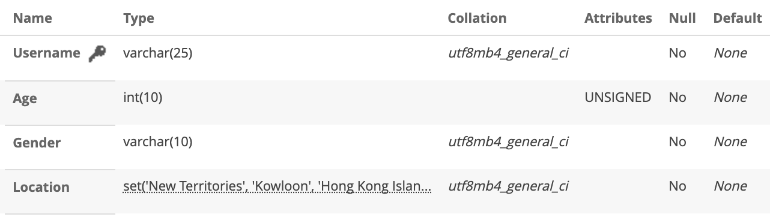

* **Gift**

It saves the variety of gifts with the price.

For example, we have guitar, birthday cake,

diamond.

In milestone 2, we add the Price attribute in Gift to

indicate each gift’s price in Bitcoin.

* **Gift Transaction**

It allows the user to buy and to send gifts to the

broadcaster. All of these transaction will be

recorded according to the time, quantity and the

payment.

In milestone 2, we add the Cashed column to each

gift transaction. It presents as a Boolean value and it

indicates that the gift transaction had been cash out

or not.

* **Cashout**

In milestone 2, we add a new table called Cashout. It consists of Username, Time and Amount.

* Username identify the cash out record belong to who
* Time indicate the time that user cash out
* Amount record the total amount that user going to

cash out that time

* **System Flow**

**Login Flow**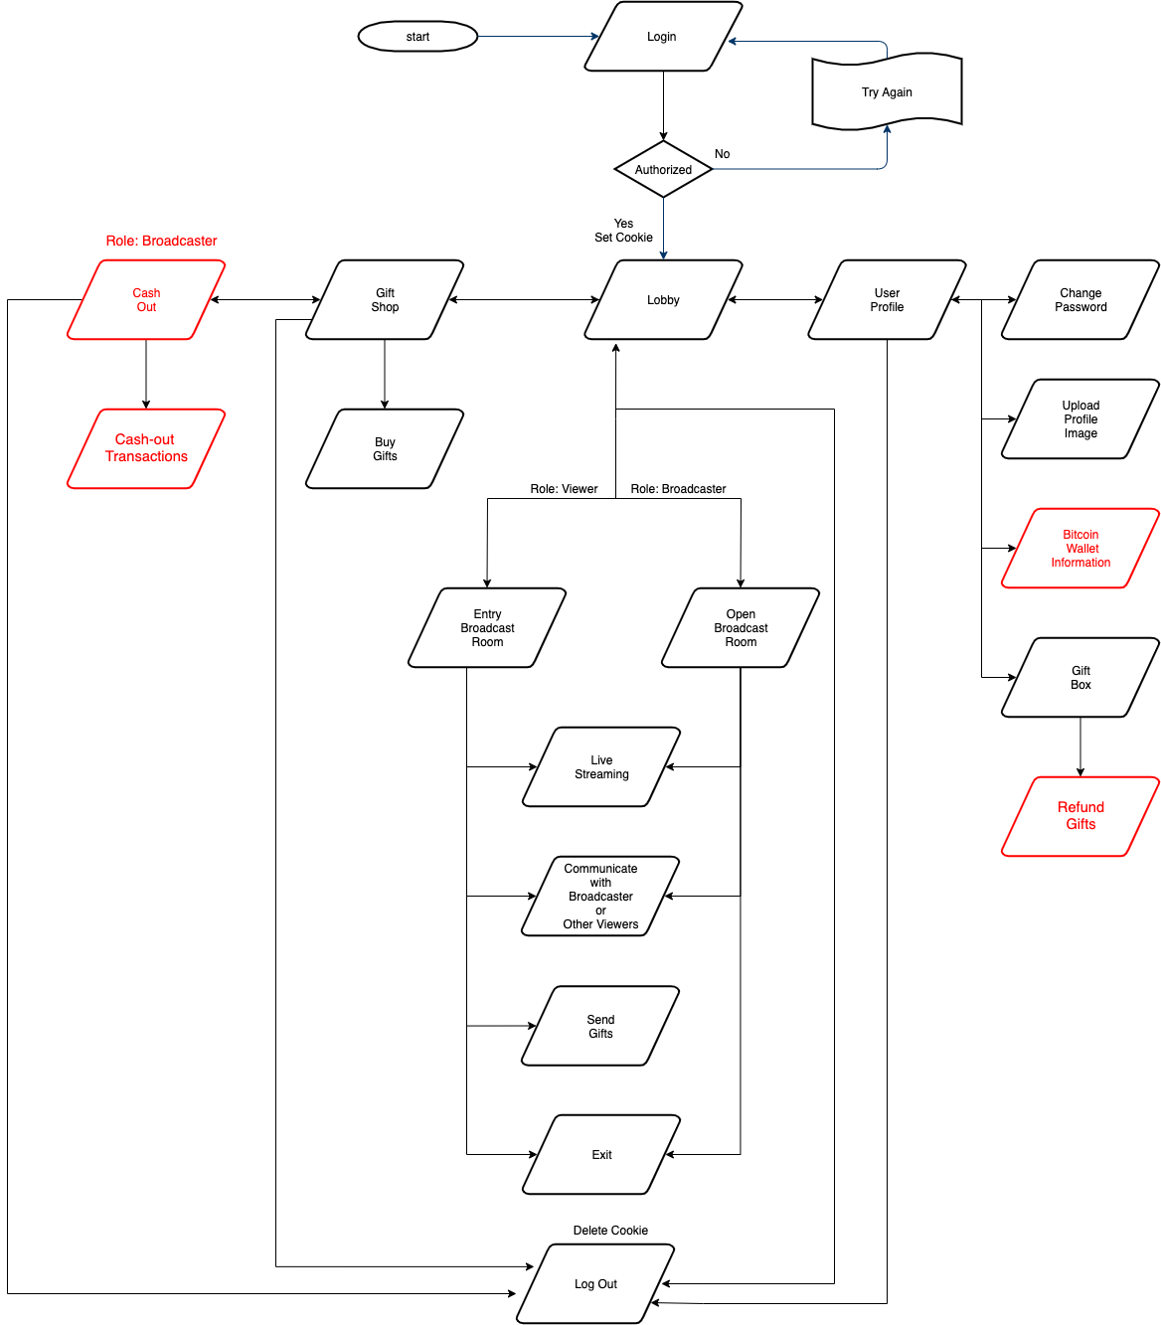

**Sign up Flow**

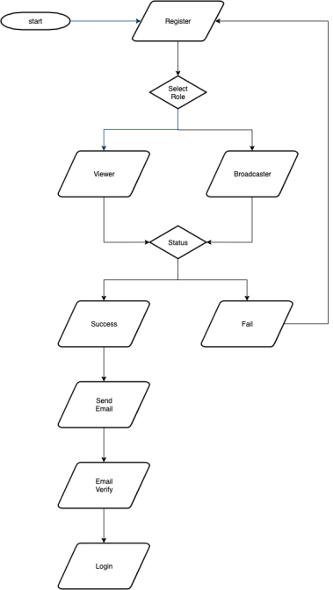

**Forget Password flow**

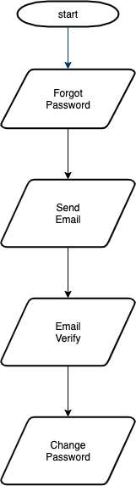

Techniques adopted during implementation

* Framework

**Bootstrap**

We use the bootstrap CSS framework for user interface. We used the responsive grid system to have a better layout.

**RTMP for broadcast live streaming**

Real-Time Messaging Protocol (RTMP) was initially a proprietary protocol developed by Macromedia for streaming audio, video and data over the Internet.

**video.js**

Video.js is a web video player built from the ground up for an HTML5 world. We used it for playing the video.

* Libraries

**Font Awesome**

It is the libraries for designing the icon. We used it to make up our application’s icon.

**Ajax**

Ajax stands for Asynchronous JavaScript and XML. AJAX allows web pages to be updated asynchronously by exchanging data with a web server behind the scenes. We used Ajax to send submit the form asynchronously without refresh the browser.

**Ratchet**

Ratchet is a loosely coupled PHP library providing developers with tools to create real time, bi-directional applications between clients and servers over WebSocket’s. We used the ratchet for message communication in the chatroom.

**BlockCypher API**

BlockCypher is a simple, mostly RESTful JSON API for interacting with blockchains, accessed over HTTP. It supports Bitcoin Testnet3. We used it for check wallet balance and create transaction between our users.

* Website

**SSL For Free** ( <https://www.sslforfree.com> )

We visit SSL For Free then enter our domain name and follow the procedure to gain the SSL certification.

**Why No Padlock?** ( <https://www.whynopadlock.com> )

Check whether all web contents are secured by https.

**Qualys SSL Labs** ( <https://www.ssllabs.com/ssltest> )

SSL Report of our website certificate information and security level.

Challenges & Solution

**Login system – Email Activation**

At first, we are not able to use the email for activating the login account. After researching, we found that we need to adjust the google security settings, also, the adjustment is lasted for 1-hour peer account before we can use the web application though the SMTP.

After that, the email activation for the login/sign-up system works well. However, after many trials of testing. Email activation no longer works. We found that this is because the email activation through SMTP server has a limit and we exceed the sending number of emails. The solution to this problem is to keep create a new account and using a trusted email address, which the address is contacted without SMTP server.

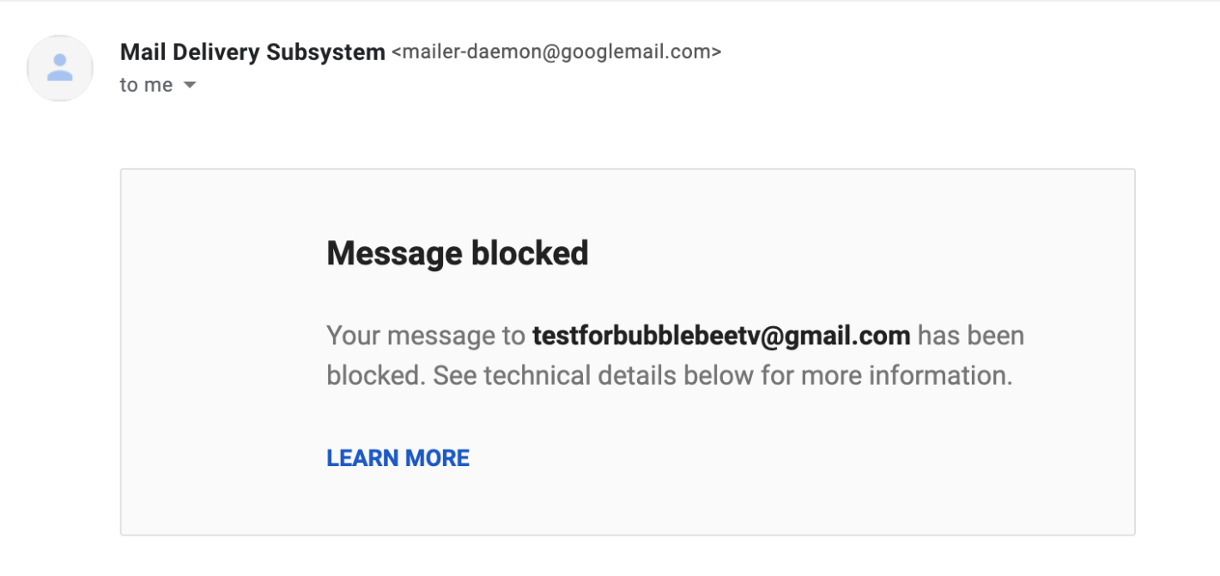

**Live broadcaster**

The first problem is that user’s stream is difficult to transfer via peer connection. After we research and reading the tutorials, we store the streaming URL in database.

Second problem is that we cannot gain the user permission for the usage of web cam. We figure out this is about the privacy settings. Google will block the camera permission for http and not allow user to change it. Finally, we use the SSL to our website such that the https protocol allows us to gain user’s permission.

Thirdly, there is browser unsupported protocol. For example, webRTC protocol is not supporting the safari. The solution is that we use the RMTP protocol to live broadcasting.

**Chatroom**

For the Real time communication. At first, we think we can use database store the data and show the message. But after we did some research, it is impossible to do that. Finally, we decide not to store at the database since there is a data redundancy and we use the web socket to achieve the real time message communication.

**Server setup**

Local host is fine, but it is difficult to make the web server online and allow peer to visit my database server for corporation. The solution is that change the settings of the XAMPP and set to router to port forwarding to my laptop.

Second, ISP assign me dynamic IP address, therefore our website does not have a static domain name. I found out that I need to set up a DDNS which give me a domain name for our server

**Integration with Block Cypher PHP API on MacOS**

As to compile the Block Cypher PHP API, we are required to use php extensions like “gmp”, “curl”, “bcmath”, “mcrypt". For PHP version 7.4.4, we must install these extensions via terminal manually. However, teacher provide us the tutorial on Linux version does not compatible on MacOS. To solve the problem, we use homebrew instead of apt-get and then make some modification on our php file, which allow the php linked to our brew package as an extension.

**Limited Bitcoin Value**

At first, our bitcoin wallet has no money. We need to get money from the websites. But the websites provide only a little bitcoin for us. After few trials, we have spent all the Bitcoins. To this problem, all our group members register more wallet accounts to upgrade the bitcoin value.

**Non-technical problem**

This project is not only combined many programming language and database, but also, we need to understand others’ coding. The problem is, using the same code, there is different result. I can compile the codes while my teammates not. Therefore, we use the Teletype package for atom to share our web with my team members and collaborate on code in real time.

**HTTPS with Bitcoin transactions**

At the beginning, we do not know why there is an error when we have Bitcoin transactions in HTTP. After research, we found that the bitcoin transactions are required the HTTPS connections. Therefore, we applied the SSL certificate on our web server first. Then, our users can create the transactions in a secure connection.

Final Results Achieved

* User Registration

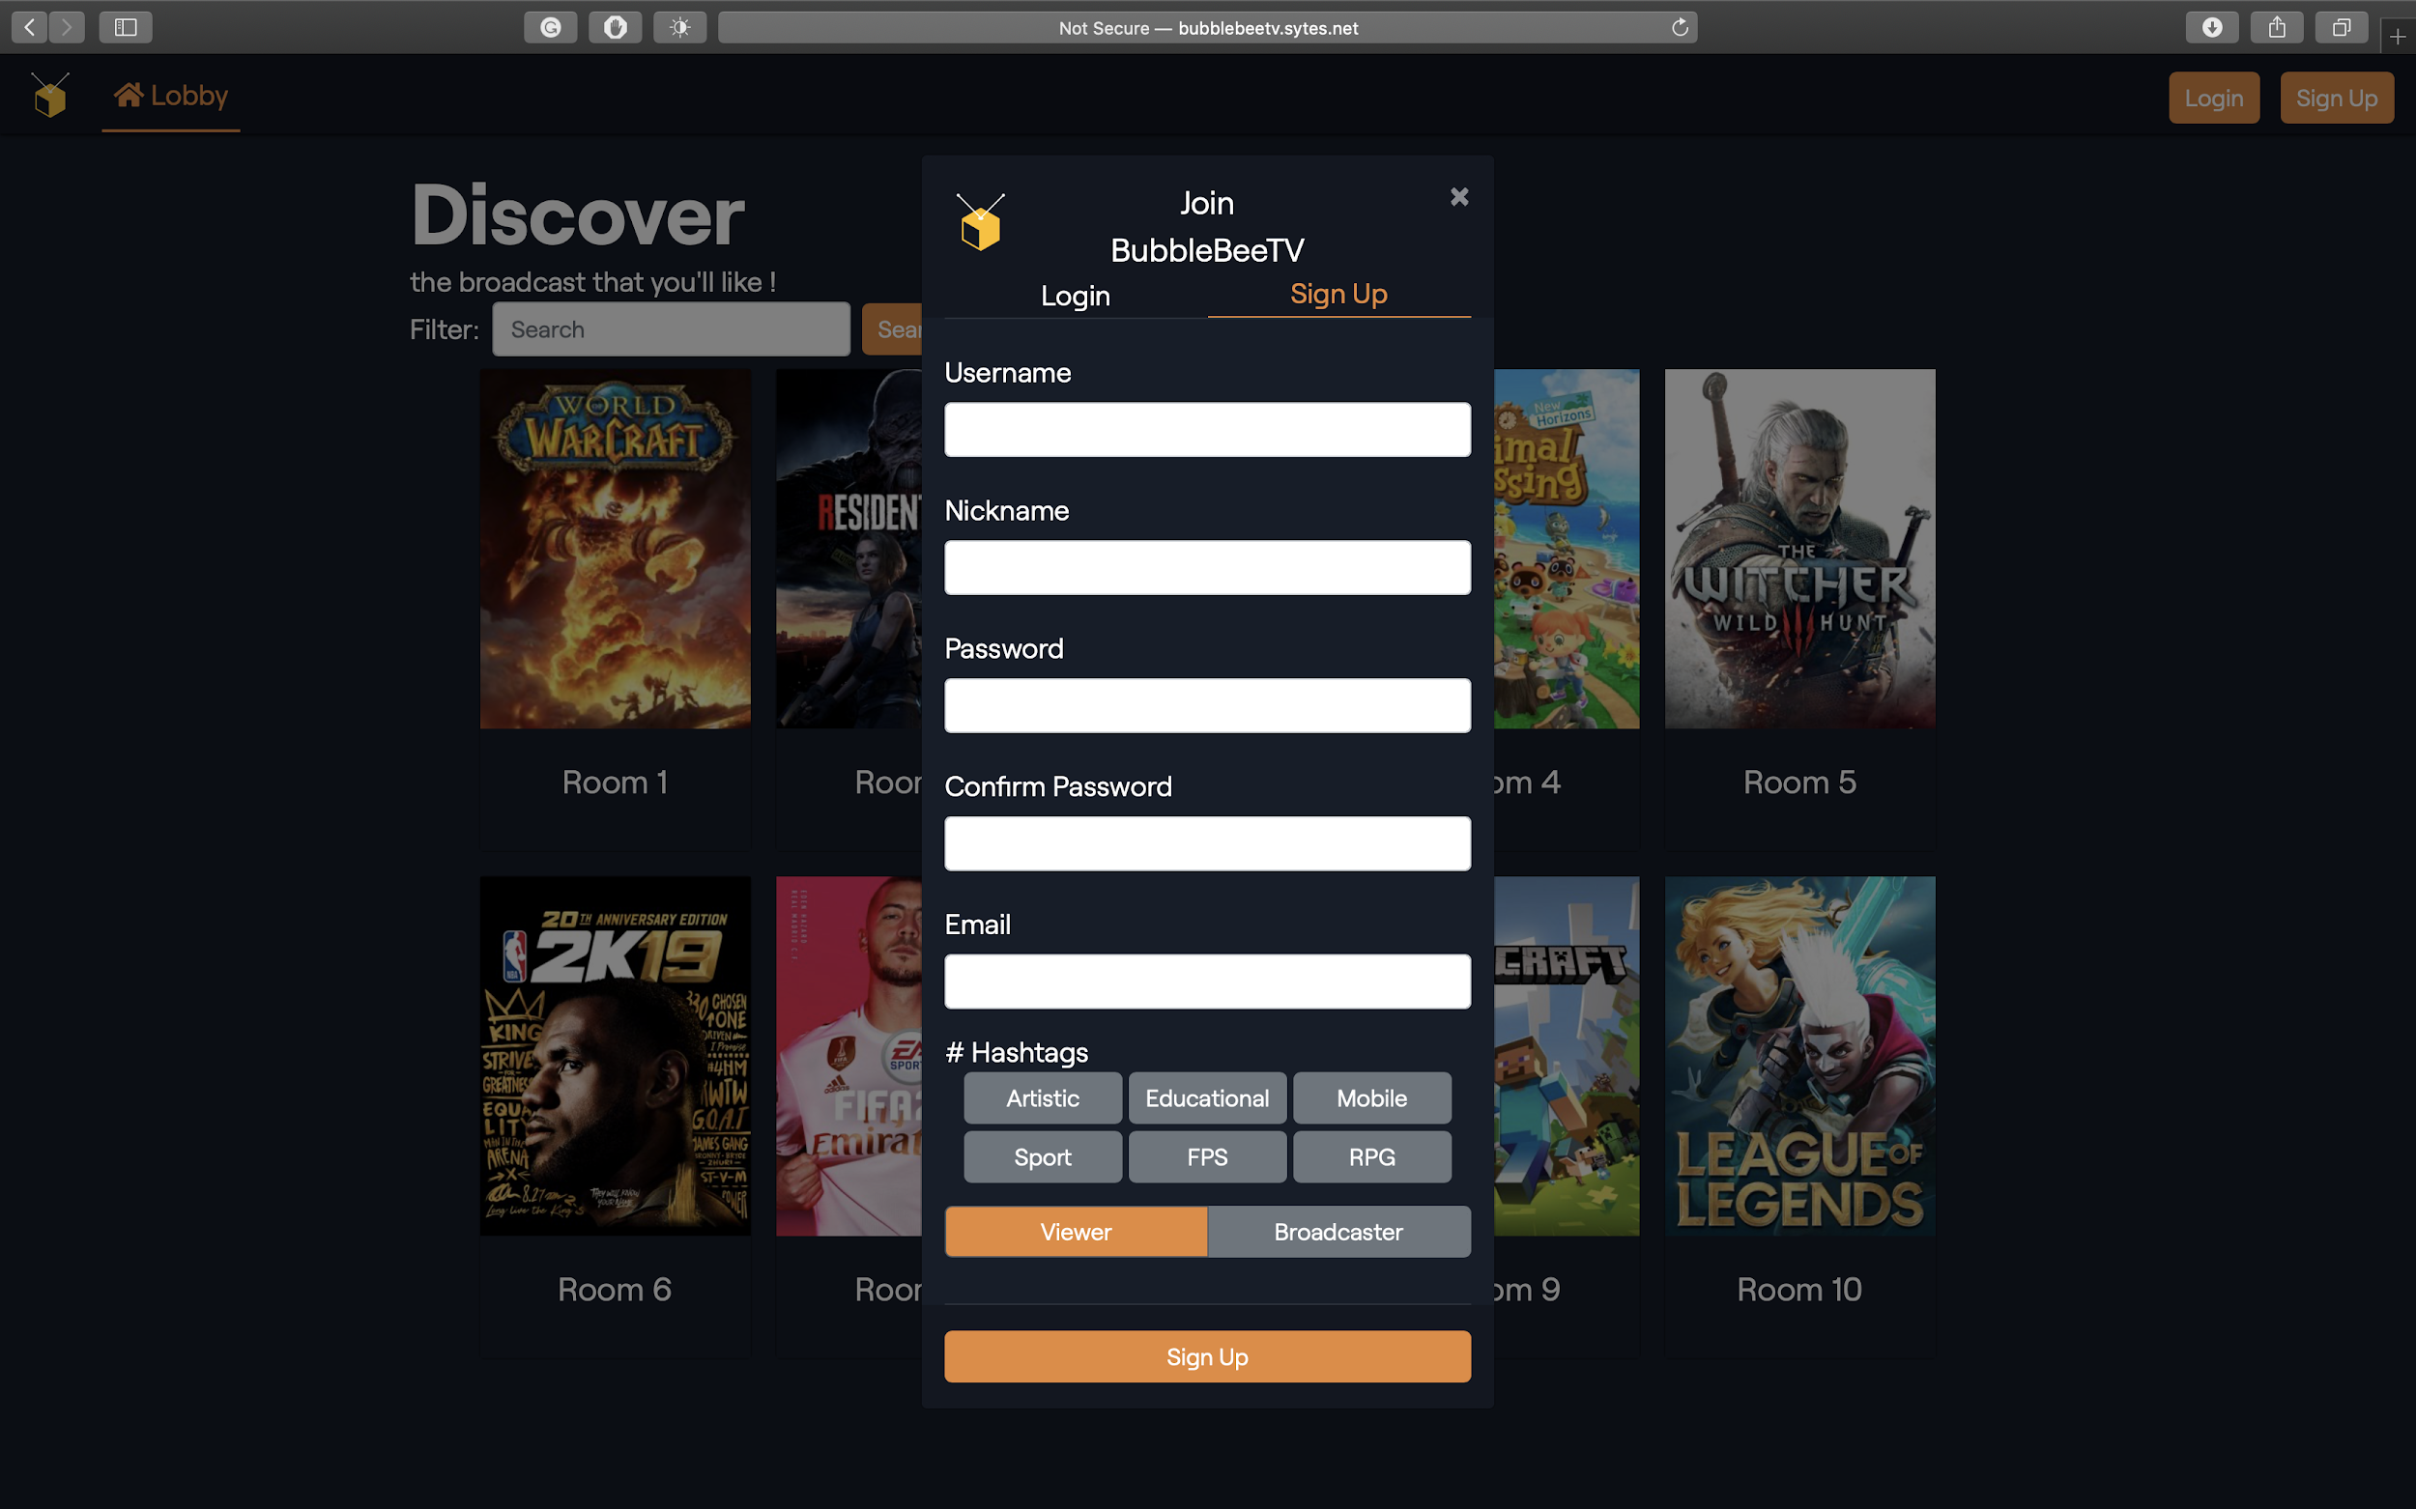

This is the sign-up page for our user, both broadcast and viewer. To be our viewer, users are required to enter their username, nickname, password, confirmed password, Email and interested hashtags for registration.

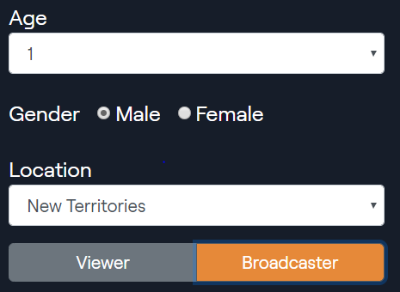

For broadcaster, they have to provide more on their personal information, such as gender, age and region.

To avoid the invalid information inputted by user, we set both client side and server-side validation.

Client-side validation: Email Format and check if any empty blanks.

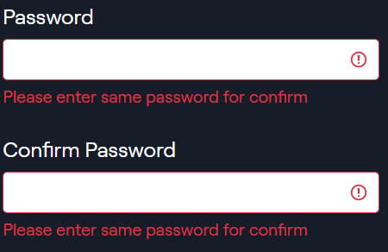

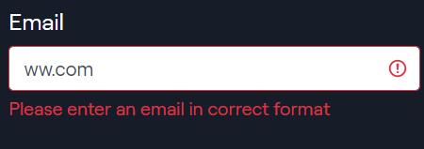

Server side: same user or same email are not allowed. User collision will be detected.

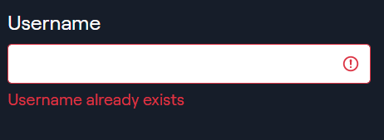

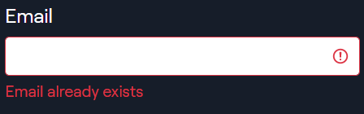

This is the Email Activation. As far as the users have signed up their account, they need to activate their account via their email address for identification. It is useful to block the fake account which created by bots.

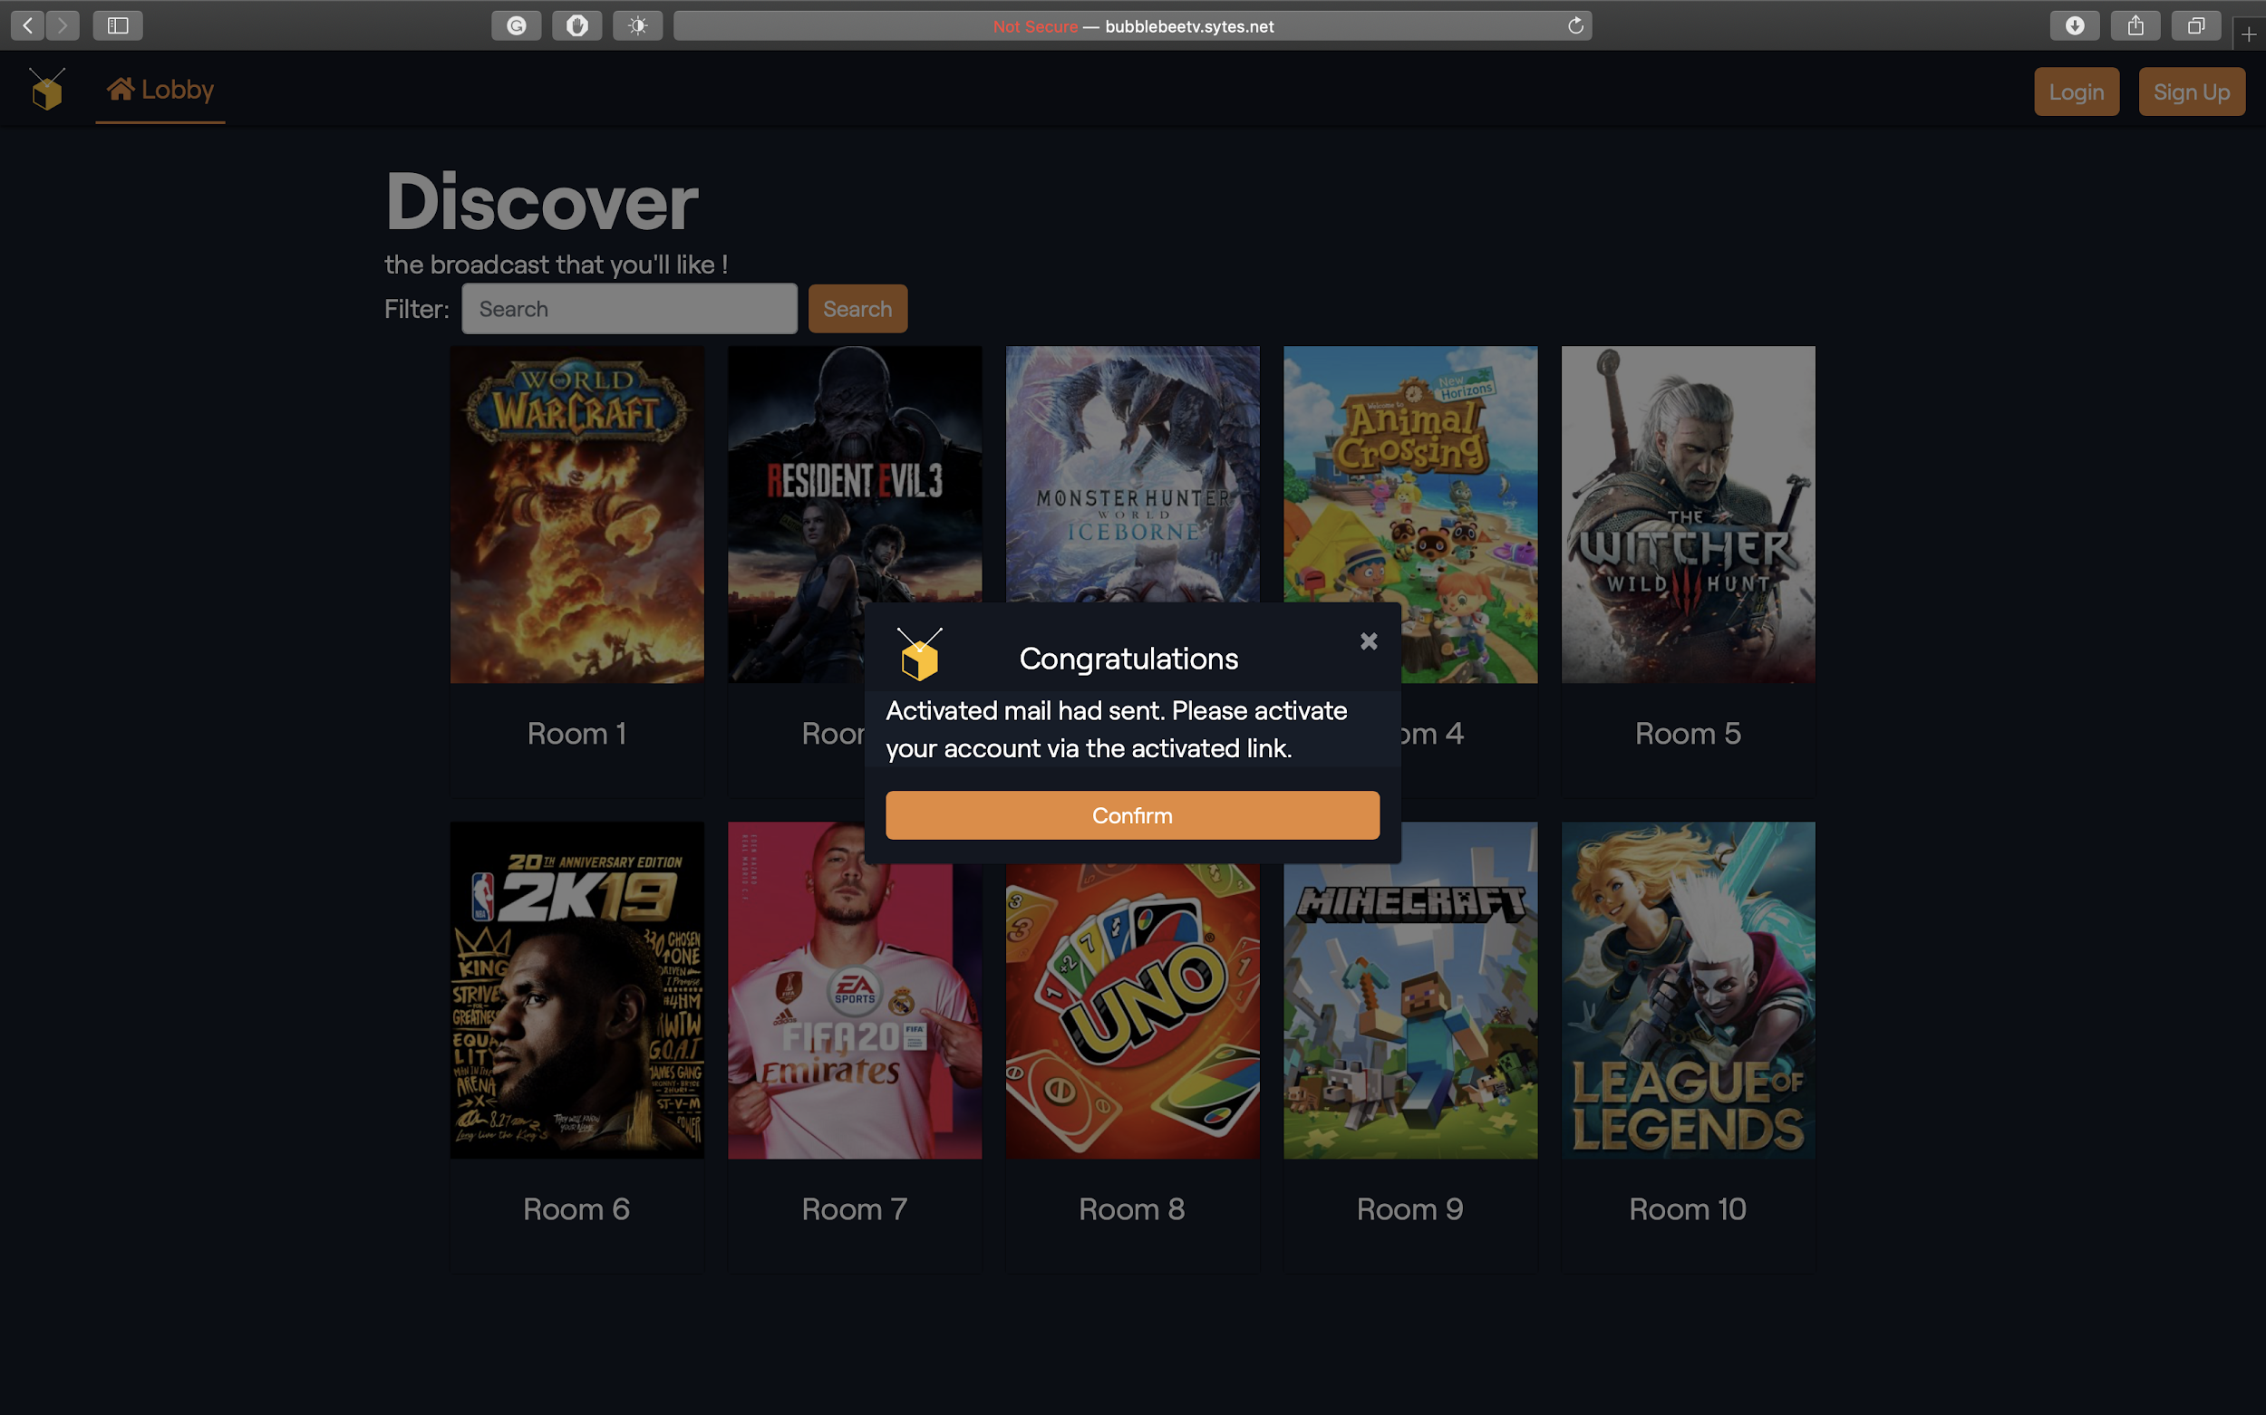

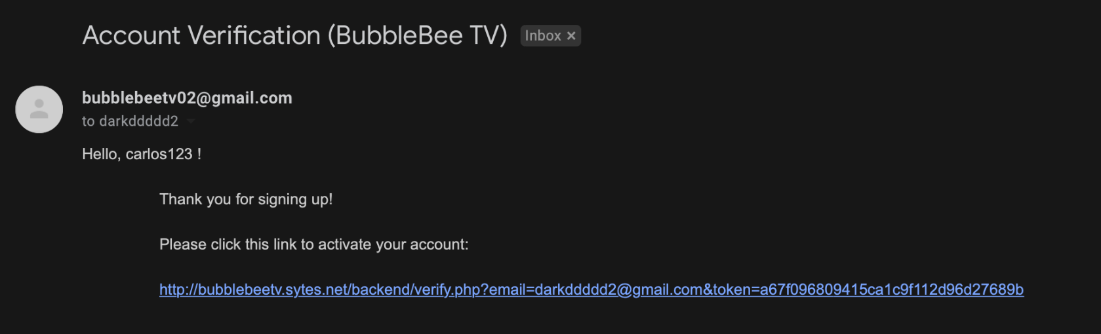

* User Login

This page is used for user to login, they are required to enter their username and password. There is also a forget password button. Once the user forgets his password, he can click it and reset his password through their signed email.

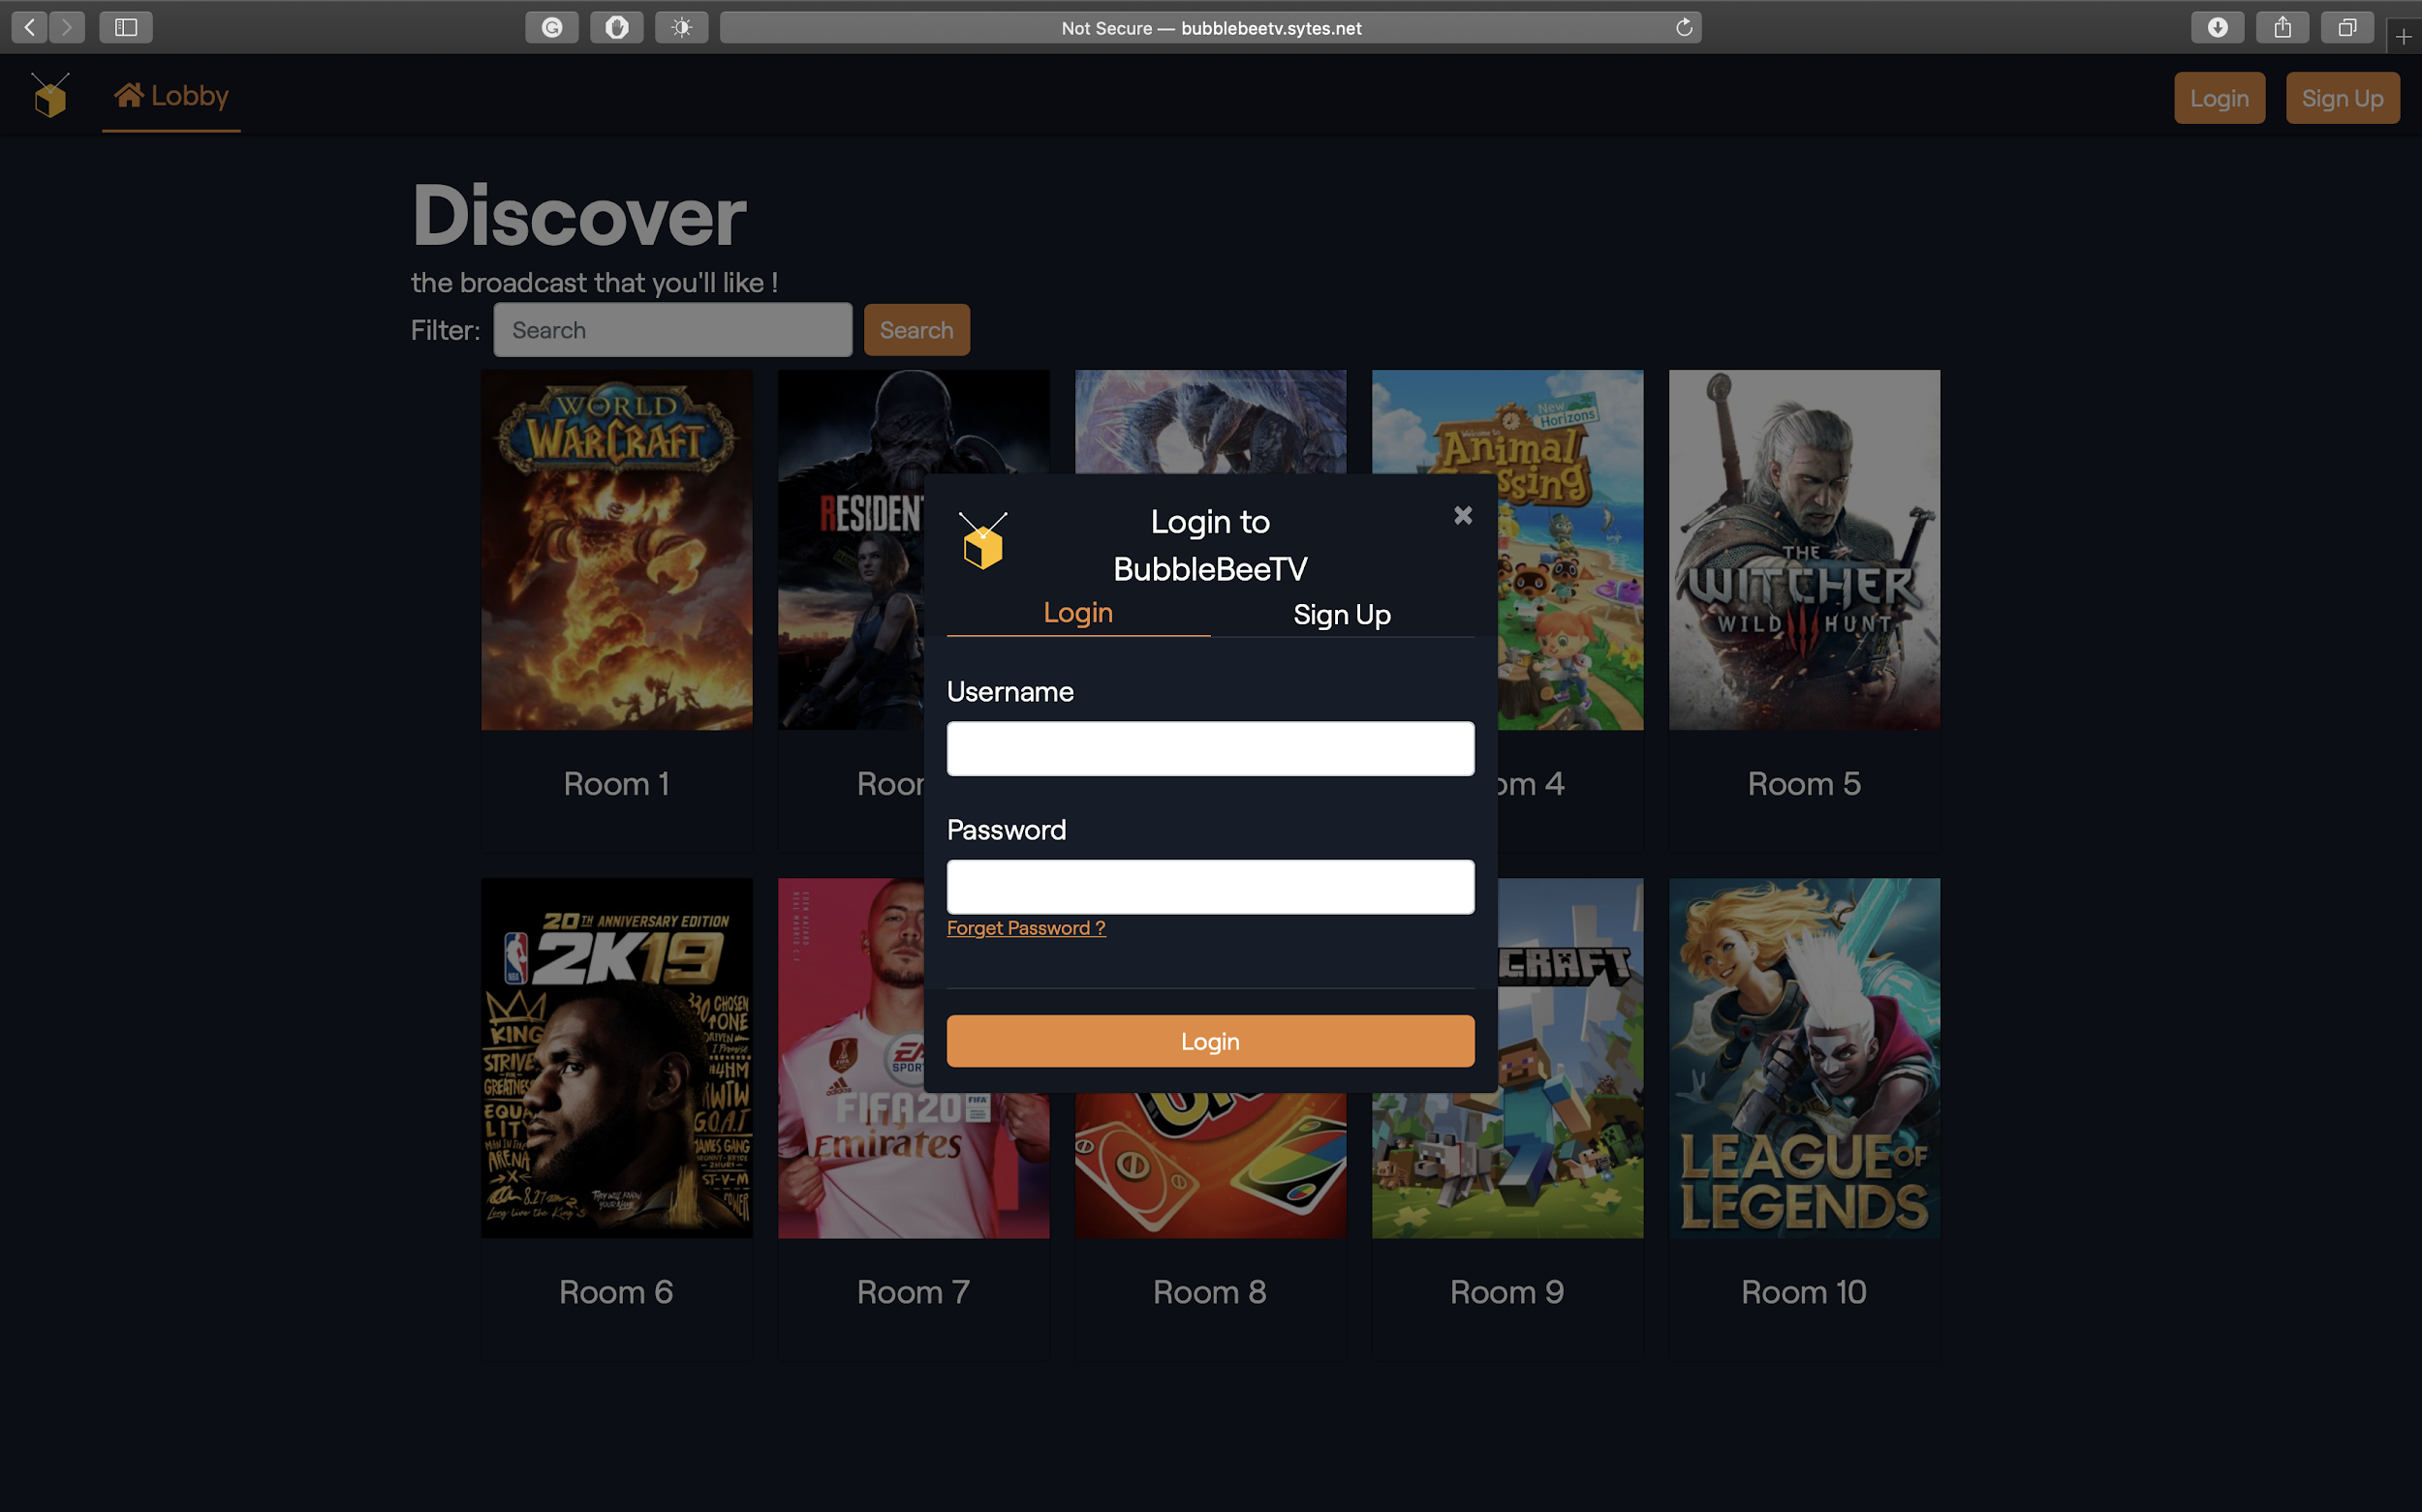

This is the situation when a user inputs the wrong username or password. A generic error message is sent back such as “Entered invalid credentials” so hackers can’t trace the error to the username or password specifically.

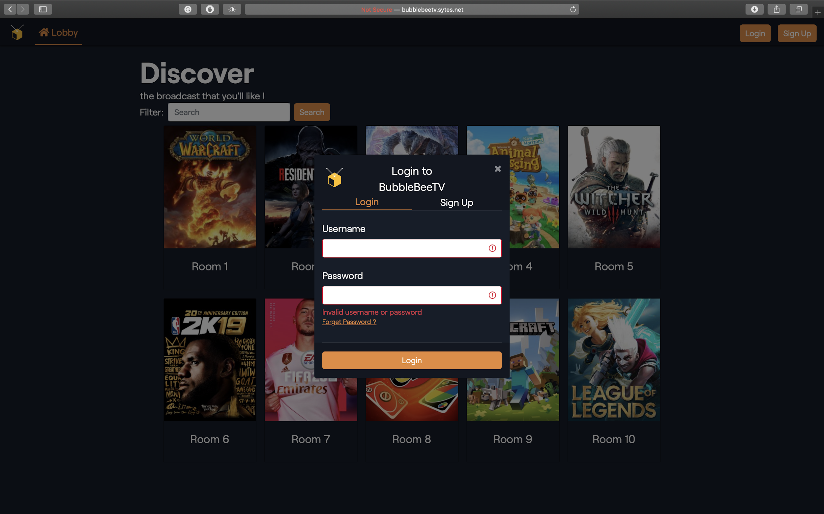

This happens when the user enters nothing in the username and password. As well as the client-side validation, it will check if the user has left any empty blank and remind the user.

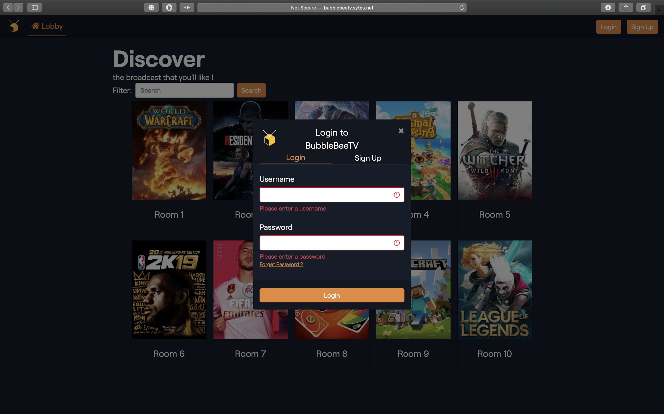

The pop out screen is to show that the website login status is using cookies. User is remained in his account until he presses the logout button.

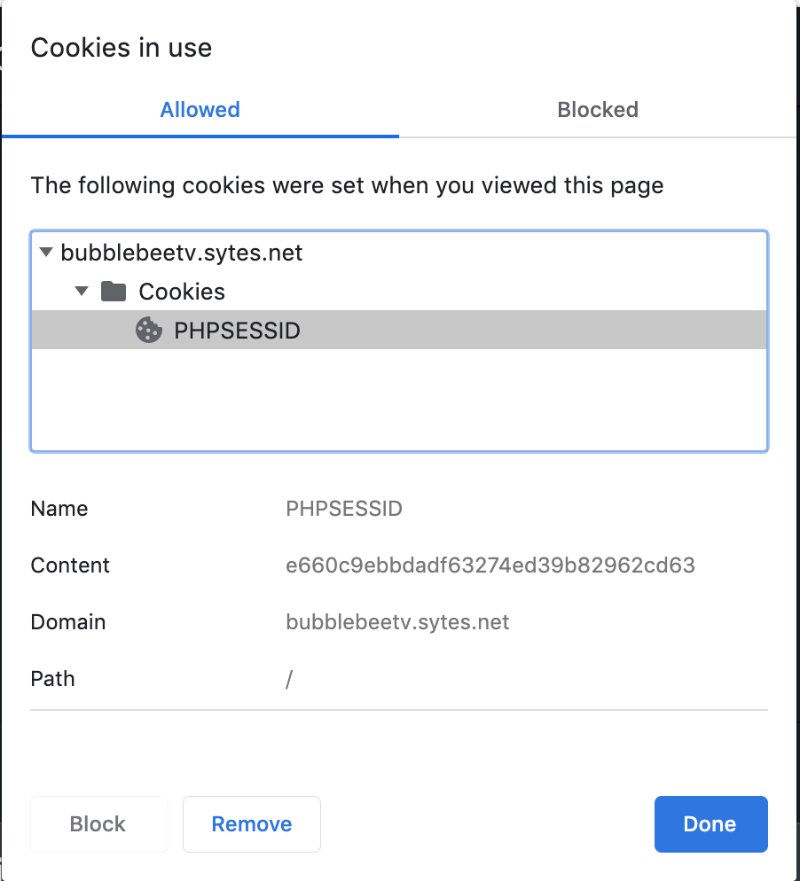 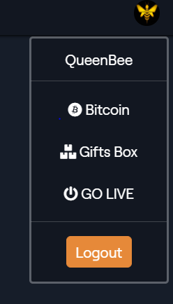

There is a logout button for users to logout. It used to delete cookie and user login information.

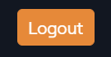

Once if the user forgets his password, he can click the “forget password” button. The schedule is shown below:

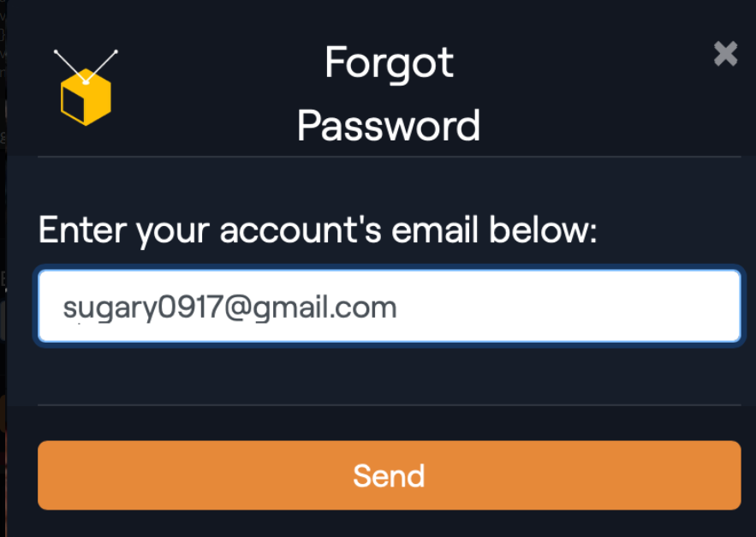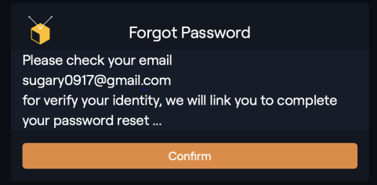

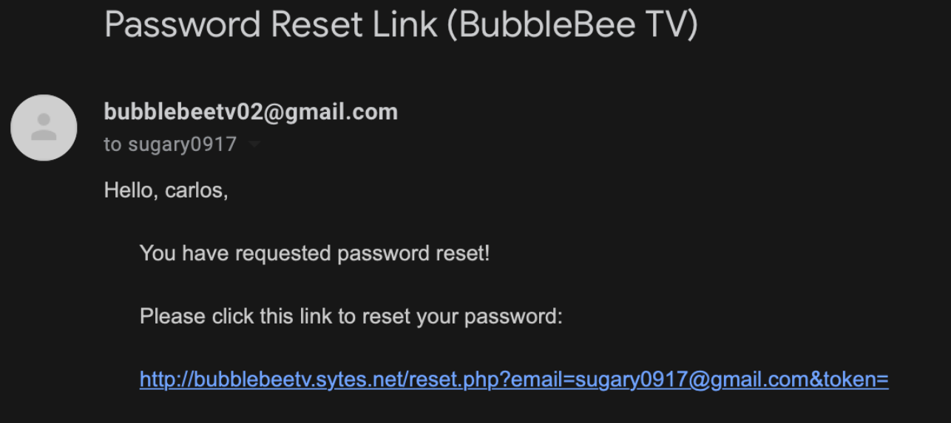

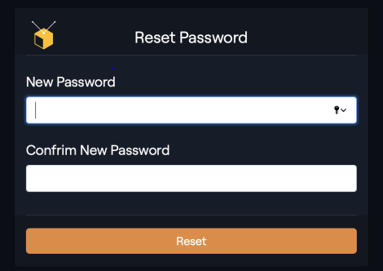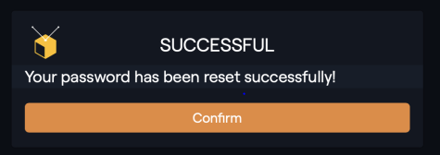

After login successfully, user can view his profile and user information.

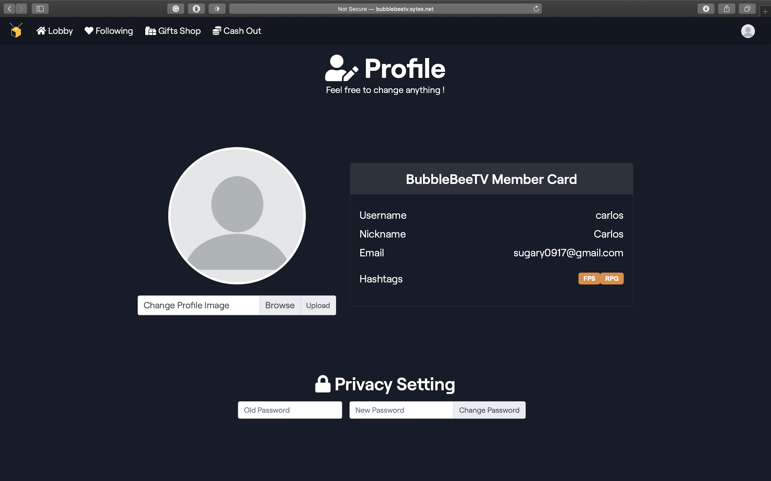

User can change their icon after login successfully.

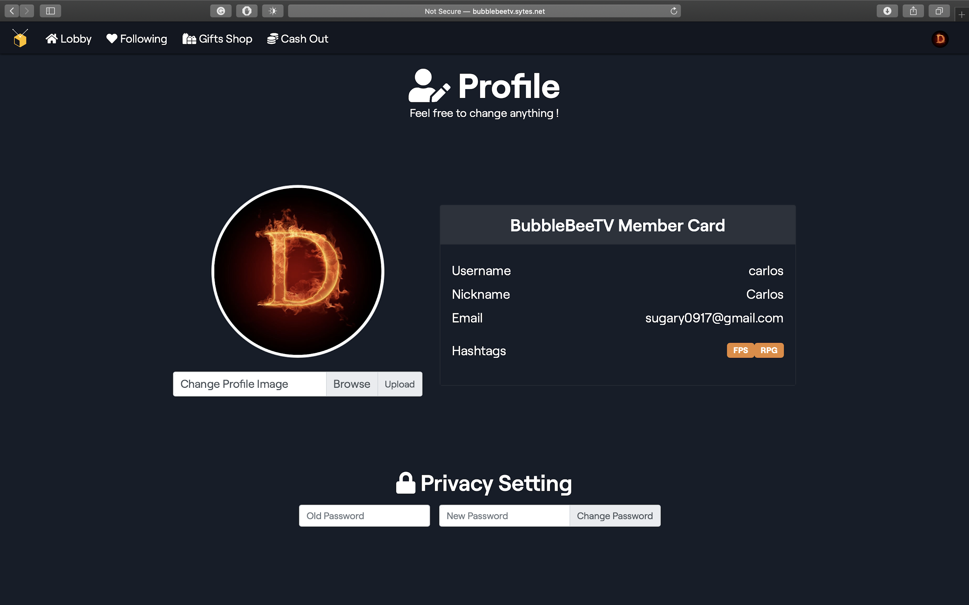

* 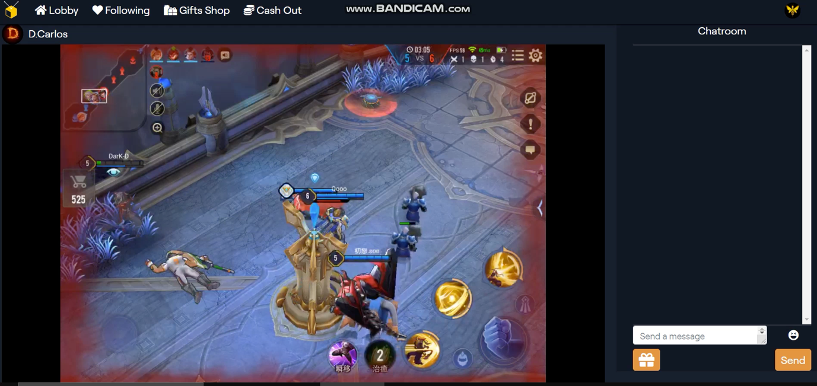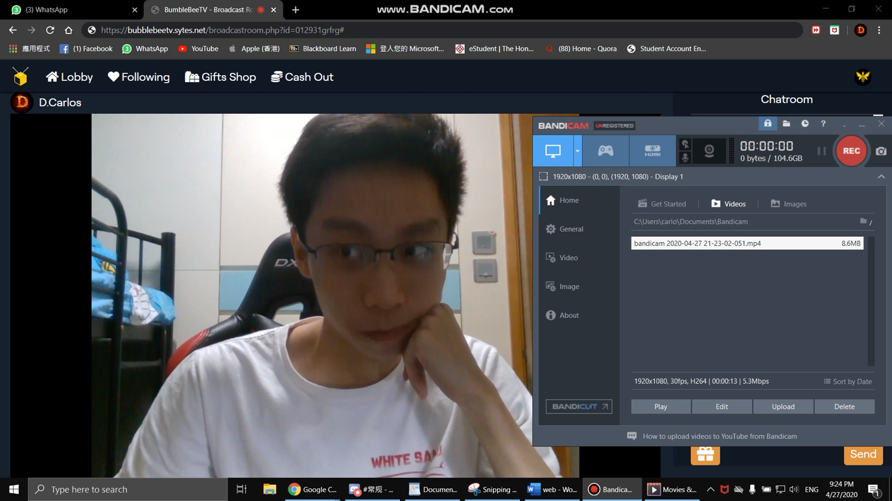Broadcaster Room
* User ( viewer ) enter Chat Room

This is the lobby. Viewer can choose which chat room to enter.

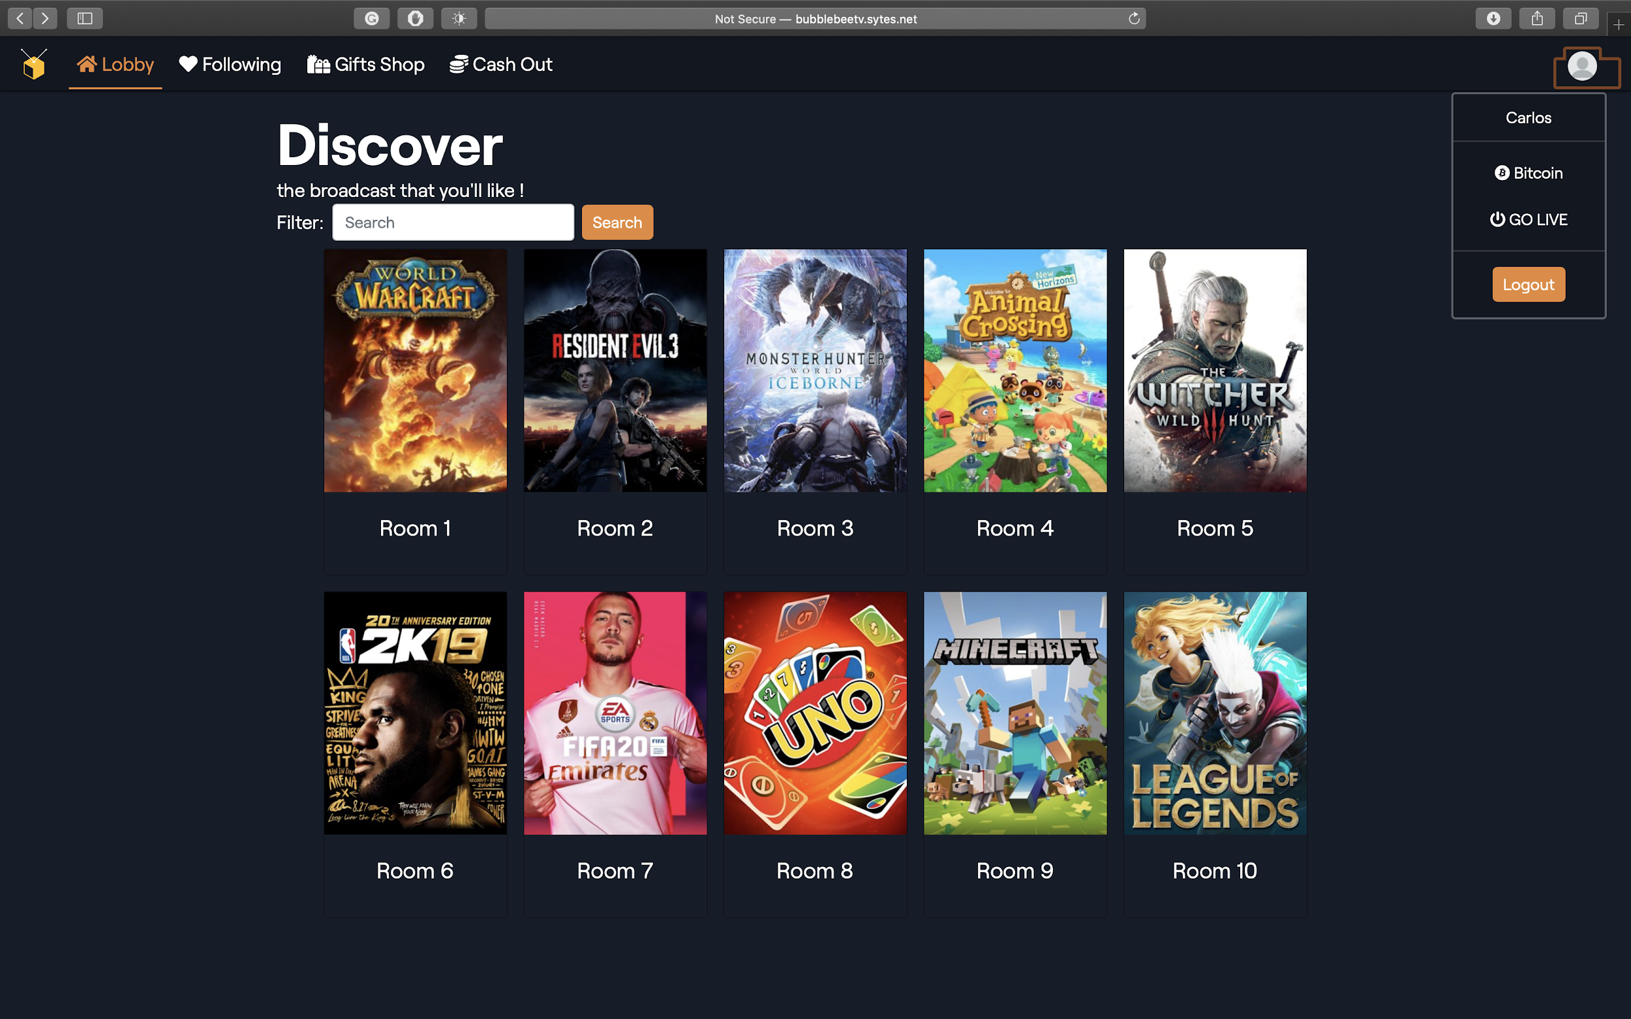

There are a lot of broadcast rooms in the lobby. We can see that there are different rooms with different categories. Viewers can choose any room to enter by clicking the room card and it will return them a hyperlink with the corresponding broadcaster ID by the GET Method. As a result, the viewer will redirect to the broadcast website.

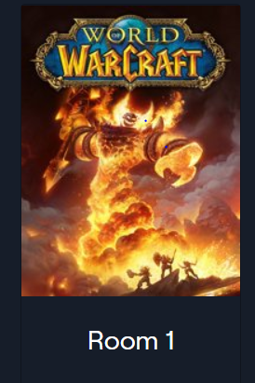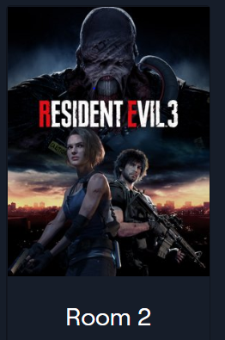



Viewers can see the streaming video and the chat history in the room at the same time.

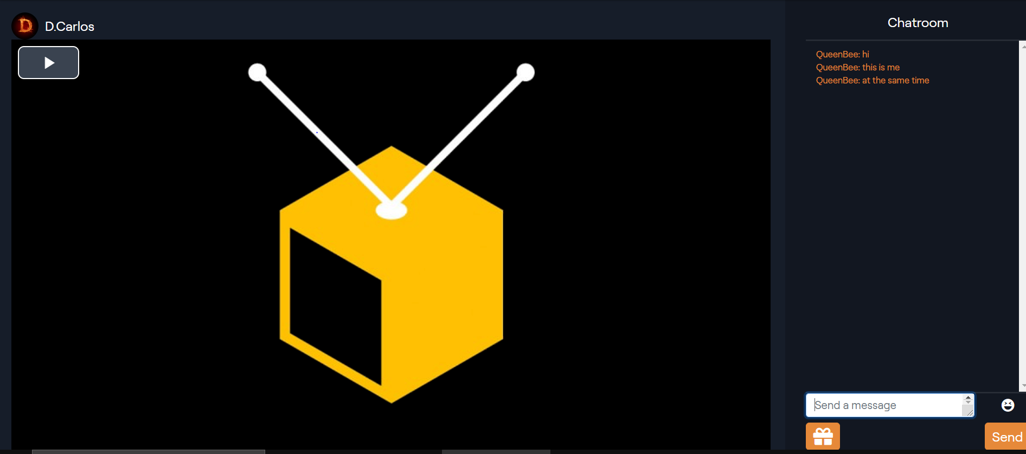

Here is the chat room. It was used for the viewer to send messages and comments. Thus, viewers and broadcasters can have more interaction.

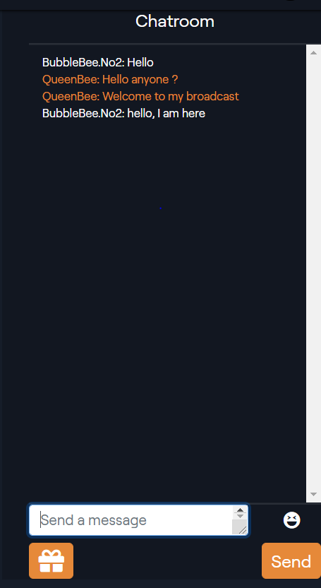

If viewers are interested in what the broadcaster is streaming, they can send gifts to them as appreciation. This page allows viewers to send gifts to broadcasters when they press the gifts button on the broadcaster streaming page.

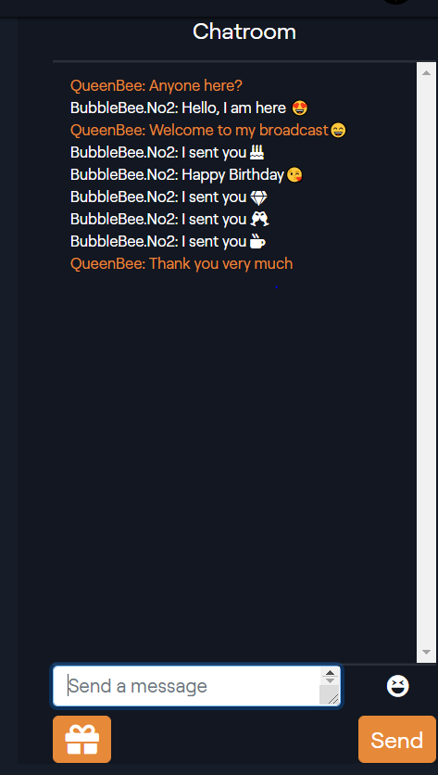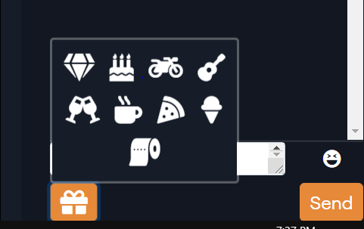

* Bind Bitcoin wallet

In the Profile page for each user, they can see their Bitcoin information in their member card.

Moreover, they can click the privacy setting or scroll down to Link To Wallet section. And input their Bitcoin wallet information to bind their bitcoin wallet to our website.

After that, user can start to create some transaction like buy, refund or cash out between their wallet and our website.

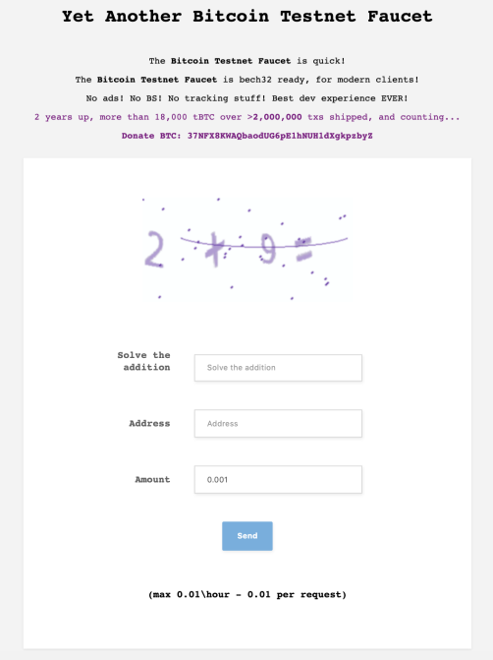

* Gift Management

In the buy gifts page, viewers can buy the gifts, like birthday cake, diamond or the guitar.

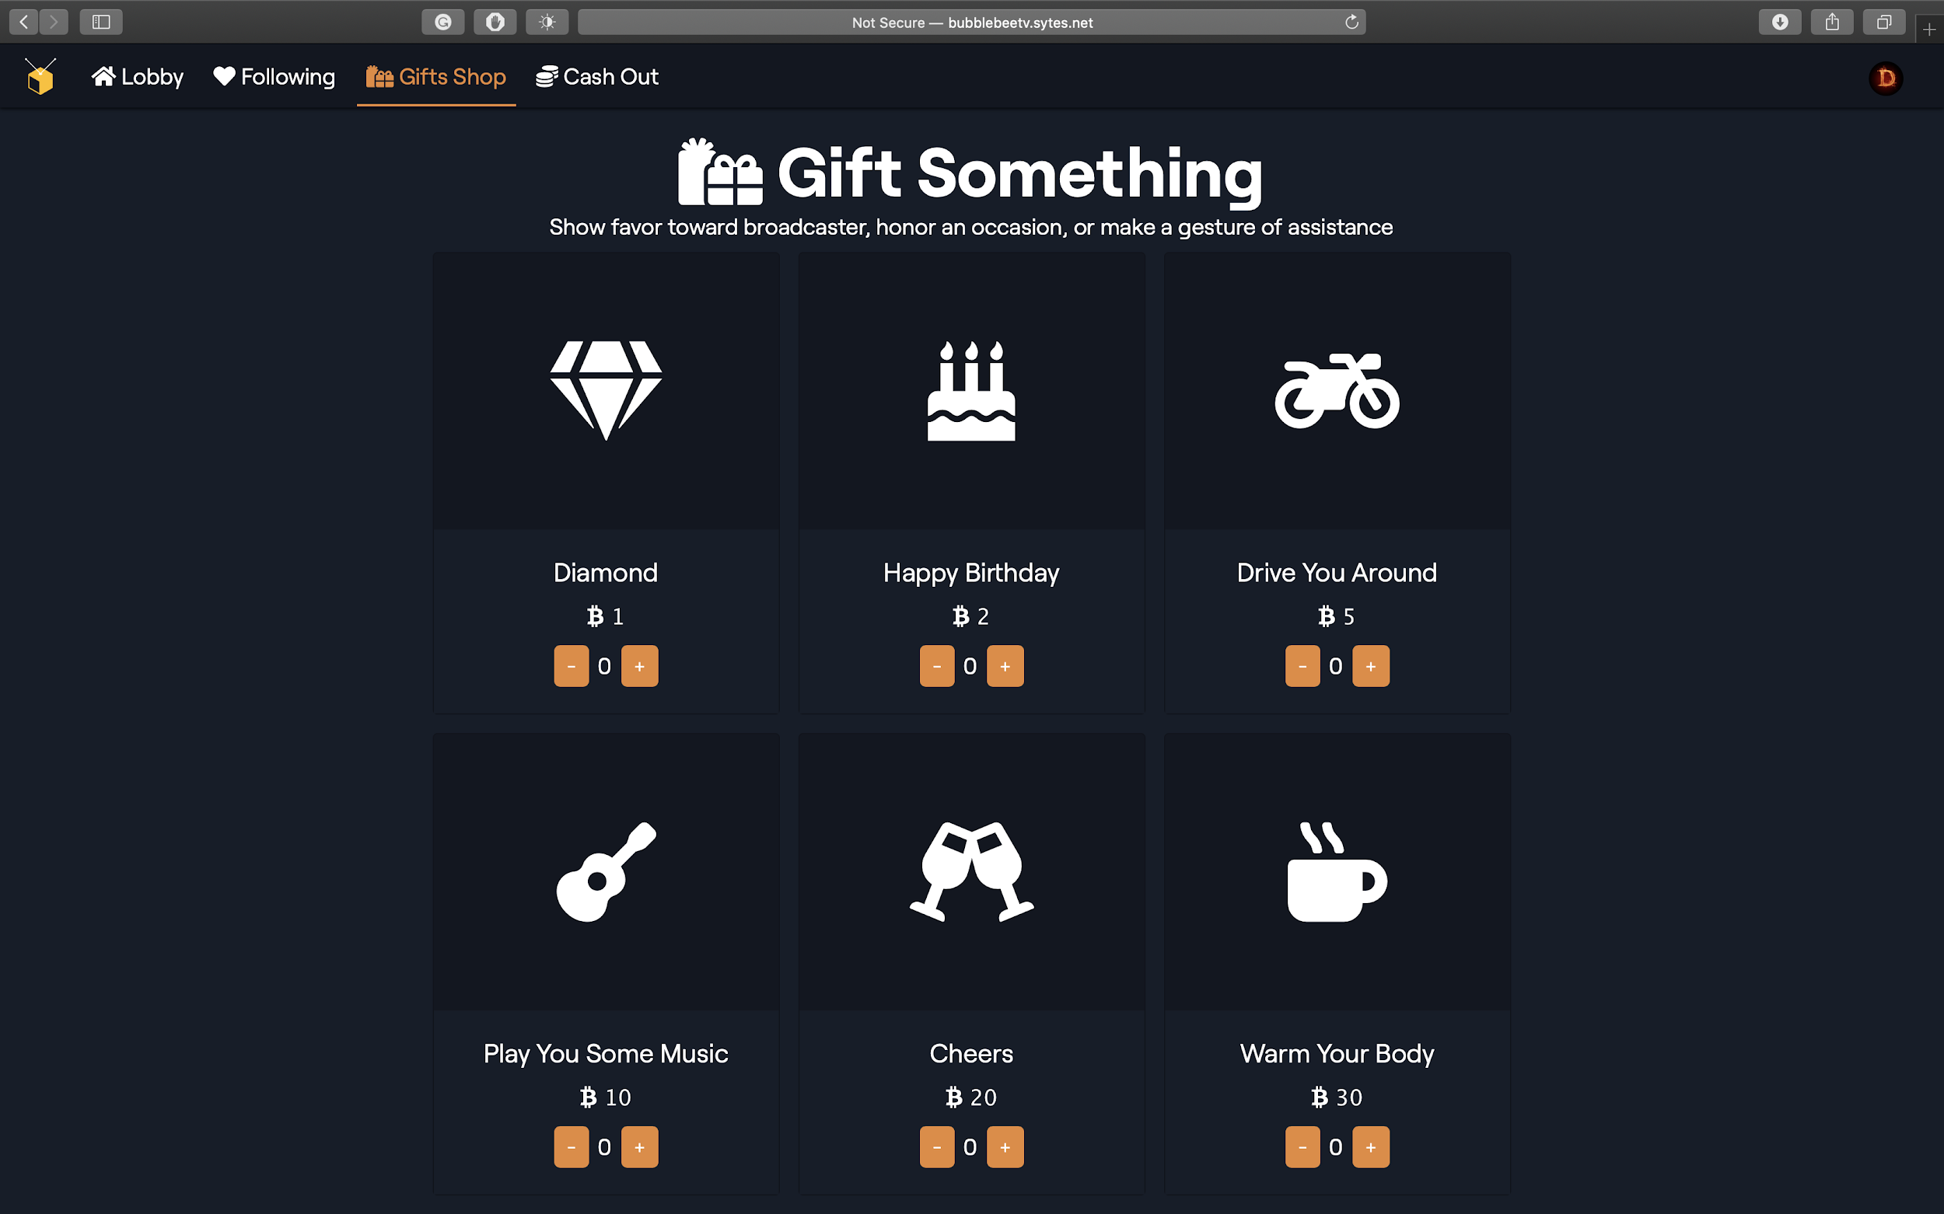

* Buy/refund gifts from/to Bitcoin wallet

In the buy gifts page, viewers can buy the gifts, like birthday cake, diamond or the guitar.

Moreover, there is a gift summary in the broadcaster room. They can view who and how many gifts have been sent by their fans so far.

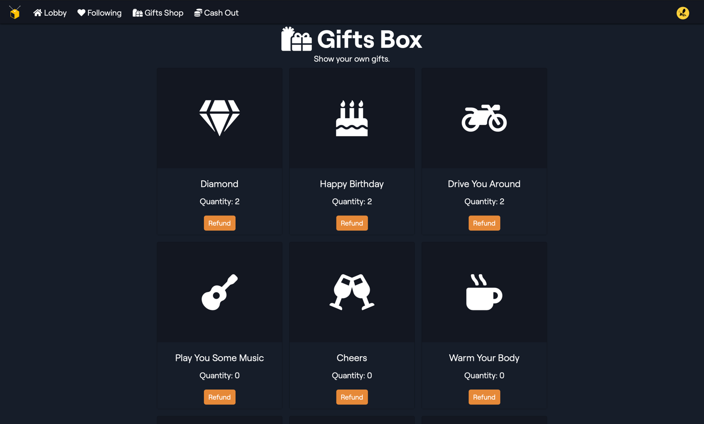

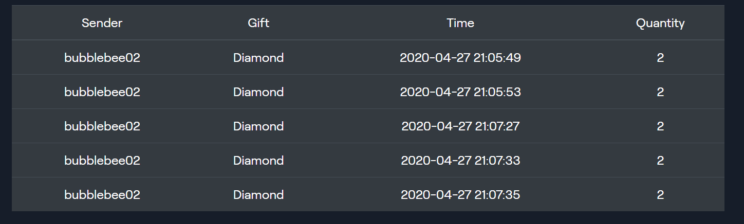

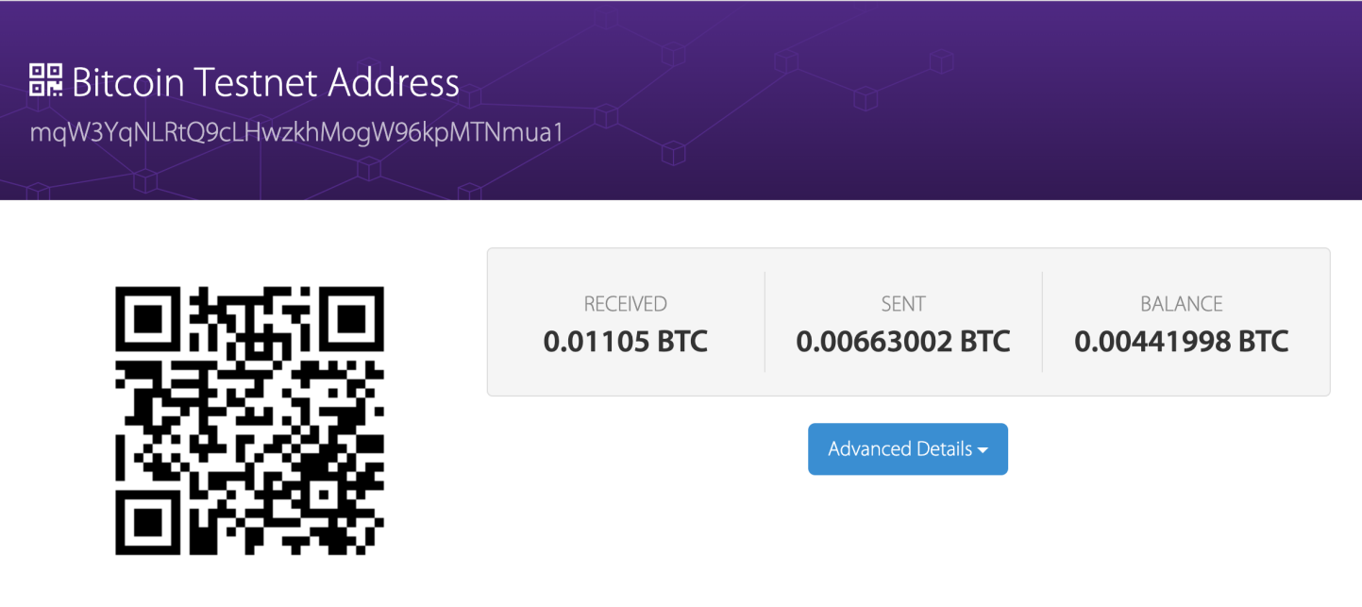

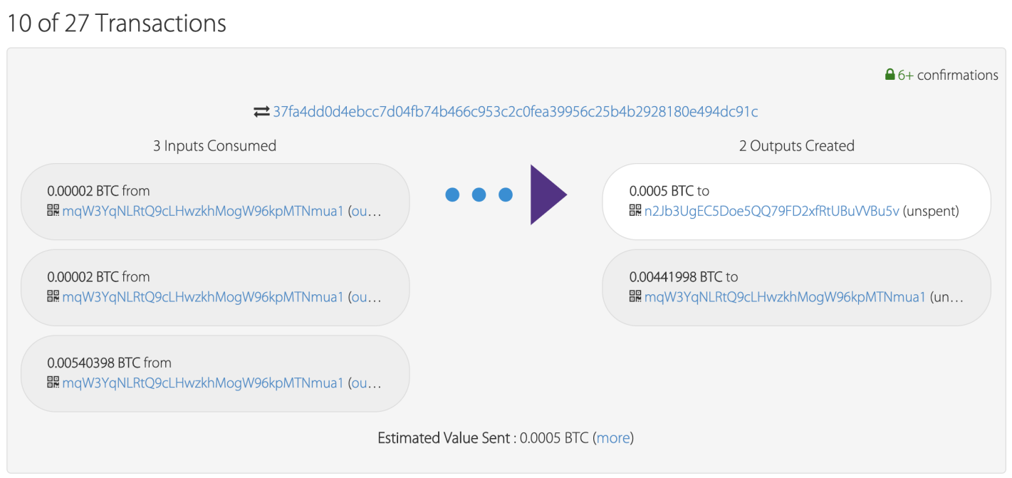

* Cash out gifts to Bitcoin wallet

* SSL Registration



* SSL Security Check

**Why No Padlock? Test Result**

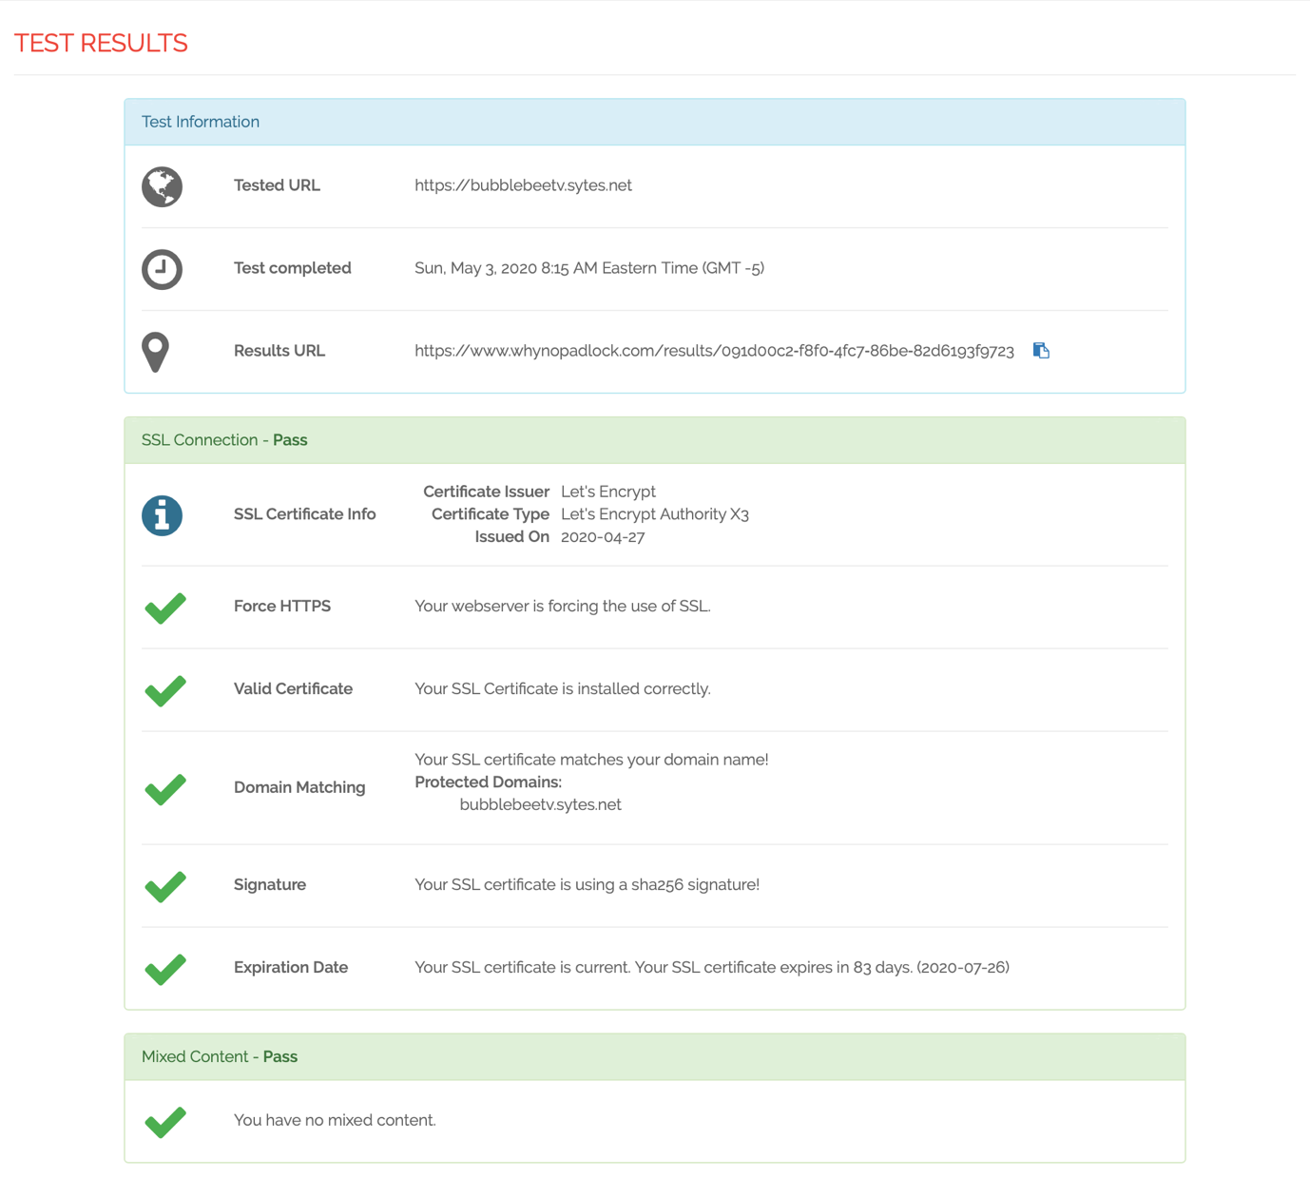

**Qualys SSL Labs SSL Report**









